Student Full Name: Abou Gbane

Student Number: ST10489481

Module Code: WEDE5020

Assessment Type: POE Part 1

Group 2

Proposal 2: Woodcraft Solutions (Small Business) 1

1. Organization Overview 1

2. Website Goals and Objectives 1

3. Current Website Analysis 1

4. Proposed Website Features and Functionality 1

5. Design and User Experience 1

6. Technical Requirements 1

7. Timeline and Milestones 1

8. Budget 1

### **Proposal 2: Woodcraft Solutions (Small Business)**

### **1. Organization Overview**

* **Name:** Woodcraft Solutions
* **History:** Founded in 2018 by a master carpenter with over 15 years of experience, Woodcraft Solutions is a Brisbane-based firm that offers custom woodworking, home repair, furniture design, and complete-home remodeling for home clients.
* **Mission Statement:** To introduce craftsmanship, quality, and integrity into each home project.
* **Vision Statement:** :To be the go-to provider of bespoke woodwork and renovations in Southeast Queensland.
* **Target Audience:**
  + Home owners
  + Interior designers
  + Property investors
  + Renovations

### **2. Website Goals and Objectives**

* **Goals:**
  + Showcase portfolio of past projects
  + Display client testimonials
  + Provide online quote request functionality
* **Key Performance Indicators (KPIs):**

|  |  |
| --- | --- |
| **Metric** | **Target** |
| Monthly visitors | 1,000+ |
| Service inquiries/month | 50+ |
| Quote requests submitted | 20+ |
| Engagement time on site | > 2 minutes |

### **3. Current Website Analysis**

|  |  |
| --- | --- |
| **Strengths** | **Weaknesses** |
| Image gallery of projects | No mobile optimization |
| Business contact details | No quote form |
| Service pages | Outdated layout |

* **Areas for Improvement:**
  + Add mobile responsiveness
  + Implement quote form and testimonial section
  + Improve visual design and navigation

### **4.** Proposed Website Features and Functionality

* Homepage
* About Us
* Services
* Testimonials
* Request a Quote
* Contact Page

### **5.** Design and User Experience

* **Colour Scheme:**Warm Brown,white, Slate Grey, Black
* **Typography:**
  + Headings: Playfair Display
  + Body: Roboto Regular
* **Layout and Design:H**igh-quality image
* **User Experience:**
  + Quick navigation
  + CTA buttons (Request a Quote, View Portfolio)
  + Mobile and desktop usability

## 6. Technical Requirements

* Domain: [www.timbercraftsolutions.com.au](http://www.timbercraftsolutions.com.au/)
* Technologies:
  + HTML5, CSS3
  + JavaScript
  + WordPress
  + Image Optimization tools

### **7.** Timeline and Milestones

|  |  |
| --- | --- |
| **Milestone** | **Date (Approximate)** |
| Proposal Submission | Week 1 |
| Research & Wireframes | Week 2–3 |
| Initial Development | Week 4 |
| Mid-Development Review | Week 5–6 |
| Final Testing & Debugging | Week 7 |
| Project Submission | Week 8 |

## 8. Budget

|  |  |
| --- | --- |
| **Item** | **Estimated Cost** |
| Domain Registration | R400/year |
| Hosting | R1300/year |
| Development | R0 |
| Maintenance | R2250/year |
| **Total** | **R3950/year** |

# Sitemap

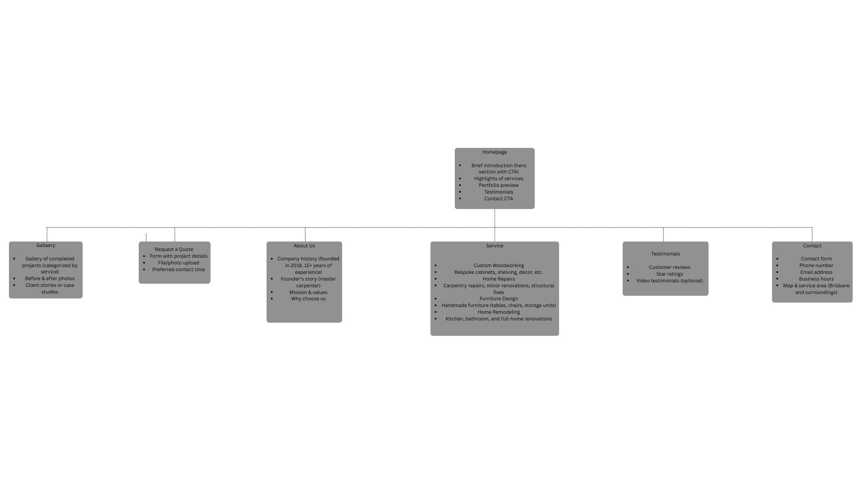

# Wireframe

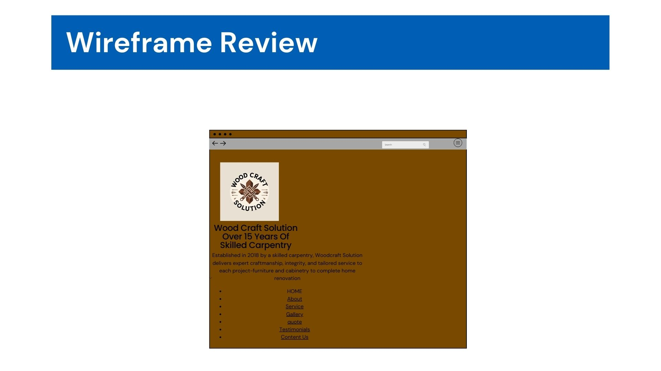

# Bibliography

**Wood bead garland, distressed shelves & hanging planters**. *JenWoodHouse.com* [image online]. Available at: JenWoodHouse.com (Accessed: 27 August 2025).

**Reclaimed wood floating shelves above a sofa**. *StartAtHomeDecor.com* [image online]. Available at: StartAtHomeDecor.com (Accessed: 27 August 2025).

**Rustic coffee / side table made from reclaimed materials**. *Marty’s Musings* [image online]. Available at: MartysMusings.net (Accessed: 27 August 2025).

**Geometric or lantern‑inspired wood decor accents**. *YouTube video thumbnail* [image online]. Available at: YouTube (Accessed: 27 August 2025).

**Modern kitchen cabinetry**. *Yelp / Custom Bookshelves Search Result* [image online]. Available at: Yelp.com (Accessed: 27 August 2025).

**Built‑in cabinetry / custom shelves**. *Yelp / Woodworking Search Result* [image online]. Available at: Yelp.com (Accessed: 27 August 2025).

**Elegant freestanding bookcase**. *VermontWoodsStudios.com* [image online]. Available at: VermontWoodsStudios.com (Accessed: 27 August 2025).

**Bright living room with built‑in shelving**. *The Spruce / Christopher Lee Foto* [image online]. Available at: The Spruce (Accessed: 27 August 2025).